**Task 1:- Command Line Weather Checking Application Documentation**

**1. Introduction**

The Command Line Weather Checking Application is a simple, yet powerful tool that allows users to retrieve weather information from various locations directly from the command line interface (CLI). This application uses a third-party weather API to provide up-to-date weather data, including current conditions, forecasts, and more.

**Key features of this application include:**

* **Real-time weather data retrieval**
* **Support for multiple locations**
* **Configurable units (e.g., Fahrenheit or Celsius)**
* **Simple and user-friendly interface**

**2. Installation**

Before installing the application make sure you have installed all the necessary libraries required using the **‘Pip’** command.

Now, to install the Command Line Weather Checking Application, follow these steps:

**1. Open a terminal window.**

**2. Clone the repository from GitHub:**

**```shell**

**git clone https://github.com/yourusername/weather-cli.git**

**```**

**3. Change to the application directory:**

**```shell**

**cd weather-cli**

**```**

**4. Install any required dependencies (if applicable).**

**3. Usage**

**# Define the URL you want to send an HTTP GET request to**

**Base_URL = “**[**http://api.openweathermap.org/data/2.5/weather?**](http://api.openweathermap.org/data/2.5/weather?)**”**

**# Send an HTTP GET request to the URL**

**response = requests.get(url).json()**

**OR**

**response = rq.get(URL).json()**

**#Url to access the weather output**

**url = {BASE_URL + “appid=” + API_KEY + “&q=” + CITYNAME}**

**OR**

**url = base_url + “appid=” + api_key + “&q=” + cityname**

To retrieve weather information for a specific location, use the following basic command:

**```shell**

**./weather.py <location>**

**```**

Replace **`<location>`** with the name of the city or location you want to check the weather for.

**4. Configuration**

The application can be configured by modifying the **‘.json()`** command codes, which is typically located in the application's directory. You can customize settings such as the default temperature units, API key (if required by the weather service provider), and other options.

Make sure to follow the format specified in the **‘.json()`** file when making changes.

**5. Examples**

Here are some example commands to demonstrate how to use the Command Line Weather Checking Application:

**- Retrieve the current weather for Delhi:**

**```shell**

**./python weather.py Delhi**

**```**

**- Retrieve the current weather for Mumbai:**

**```shell**

**./python weather.py Mumbai**

**```**

**- Retrieve the current weather for Hyderabad:**

**```shell**

**./python weather.py Hyderabad**

**```**

**6. Output of Examples**

Below are the examples of real time data that we get after executing the above commands in our environment or command prompt.

**1) Output 1**

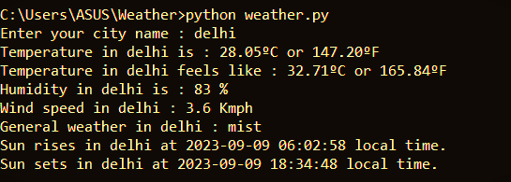

**2) Output 2**

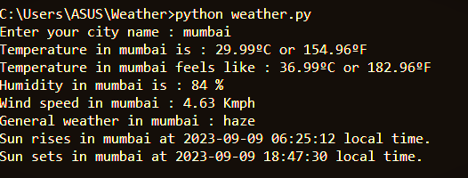

**3) Output 3**

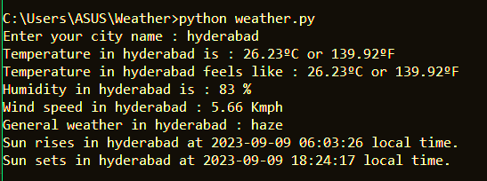

**7. Troubleshooting**

If you encounter any issues or errors while using the application, consider the following troubleshooting steps:

1. Check your internet connection.

2. Ensure that you have provided the correct location name. [‘Check for any typos’]

3. Review the configuration in the **`.json()`** file.

If the issue persists, please consult the API provider documentation or contact the support team for assistance.

**8. Frequently Asked Questions**

Visit the project’s README or openweatherapi website for a list of frequently asked questions and answers.

**9. Acknowledgments**

I would like to thank the openweatherapi community for their contributions to this project by providing the real time weather data services and APIs codes.

For more information and updates, please visit the project's GitHub repository: